

Assignment 1
Faculty of Computers and Artificial Intelligence
Introduction to Software Engineering
Section 13,14
Team names. emails. Who did what :
Task1, Word | 20240253@stud.fci-cu.edu.eg | سوسنه اسحق حبيب
Task1, Task 3, word | 20242375@stud.fci-cu.edu.eg | نوال محمود عبدالعليم احمد
Task1, Word, Task 2 | 20240001@stud.fci-cu.edu.eg | أبانوب أيهاب مرقص
Task1, Github repo, Task 3, word | 20250905@stud.fci-cu.edu.eg | يوسف أسامة سامي عزمي
Team leader number 01277606880

Task 1 | Pages 19
Task 2 | Pages 2
Task 3 | Pages 1

Task1
Language Java
7 Hours | سوسنه اسحق حبيب
10 Hours | نوال محمود عبدالعليم احمد
6 Hours | أبانوب أيهاب مرقص
6 Hours | يوسف أسامة سامي عزمي

Soussana’s app
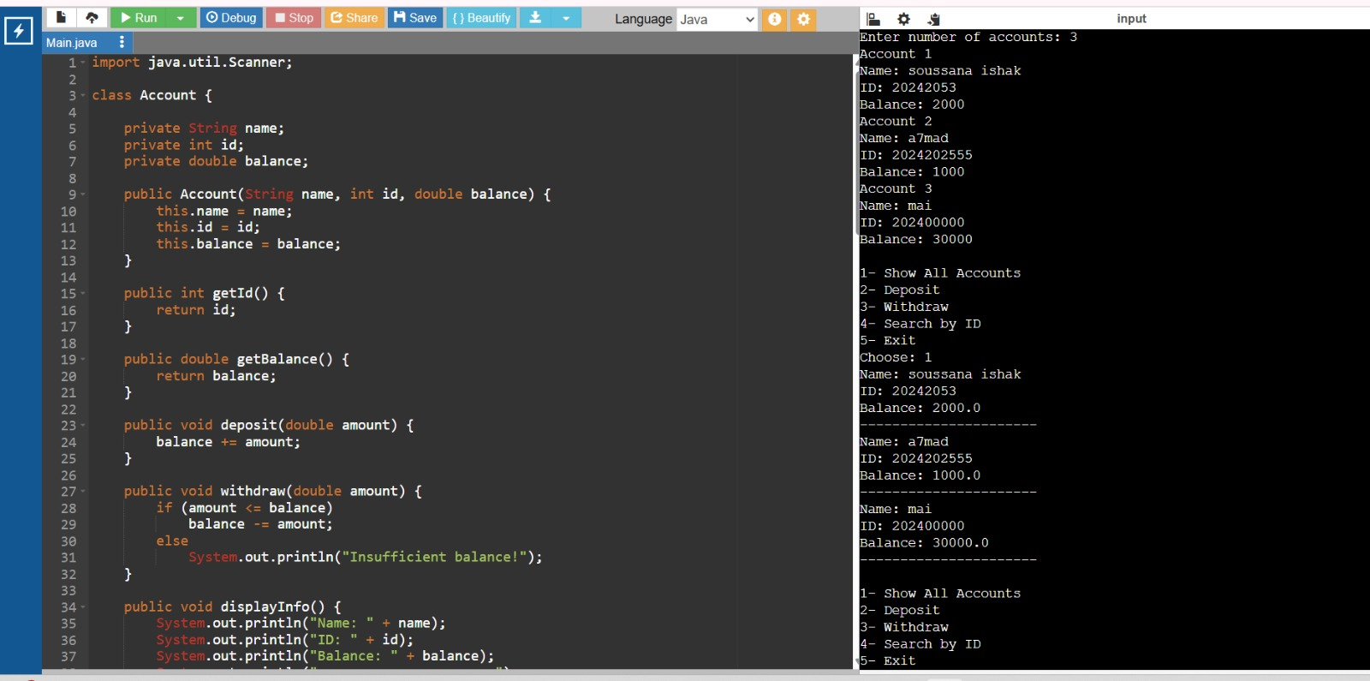

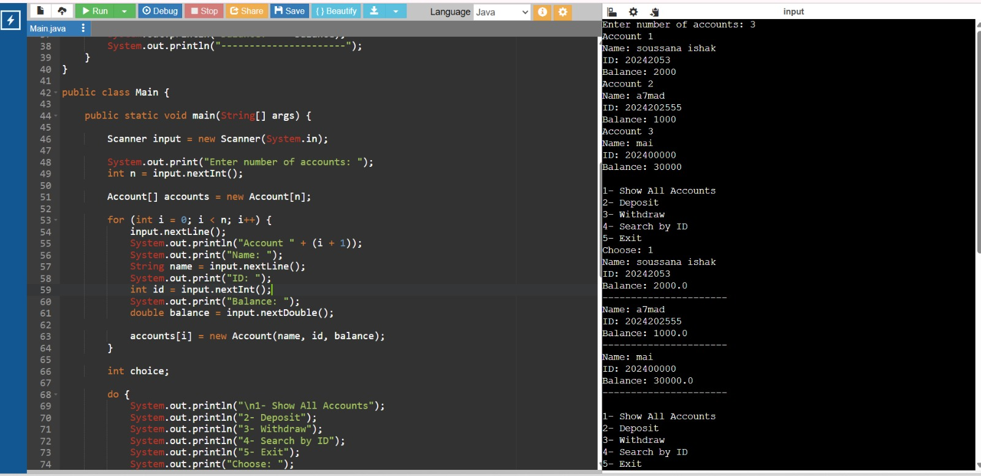

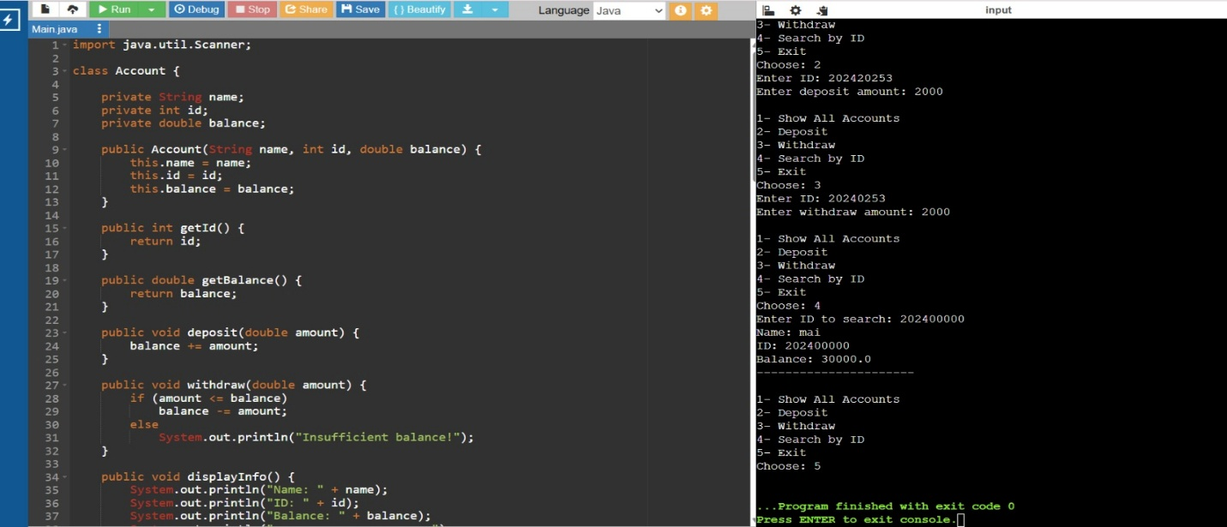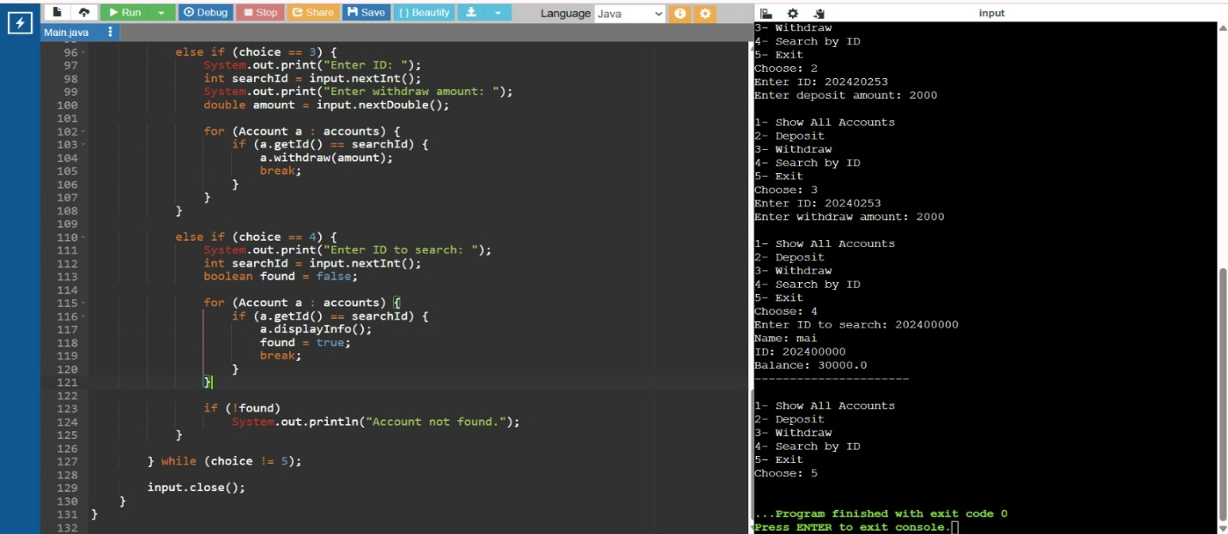
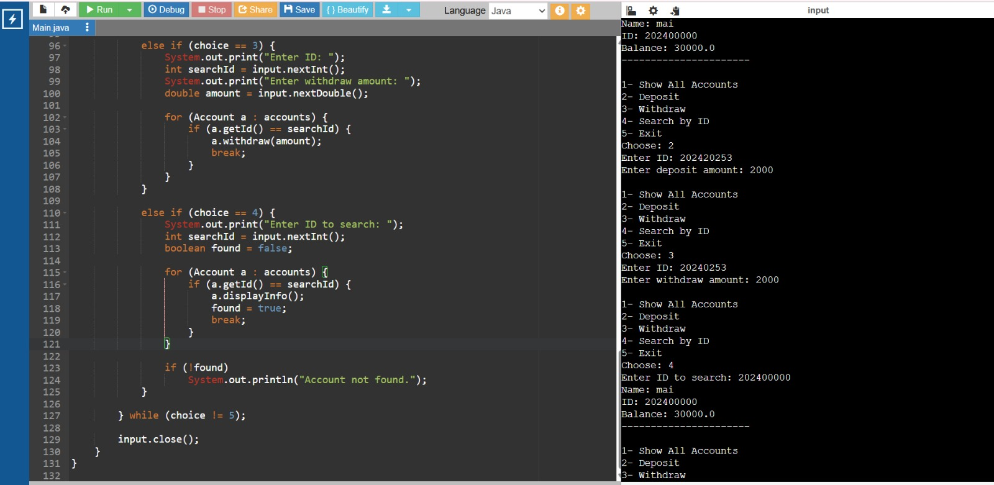
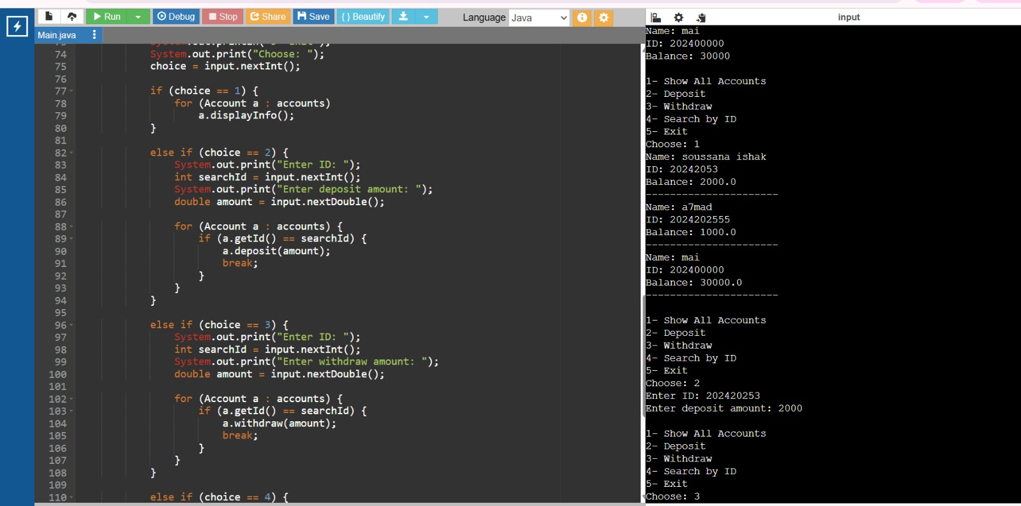

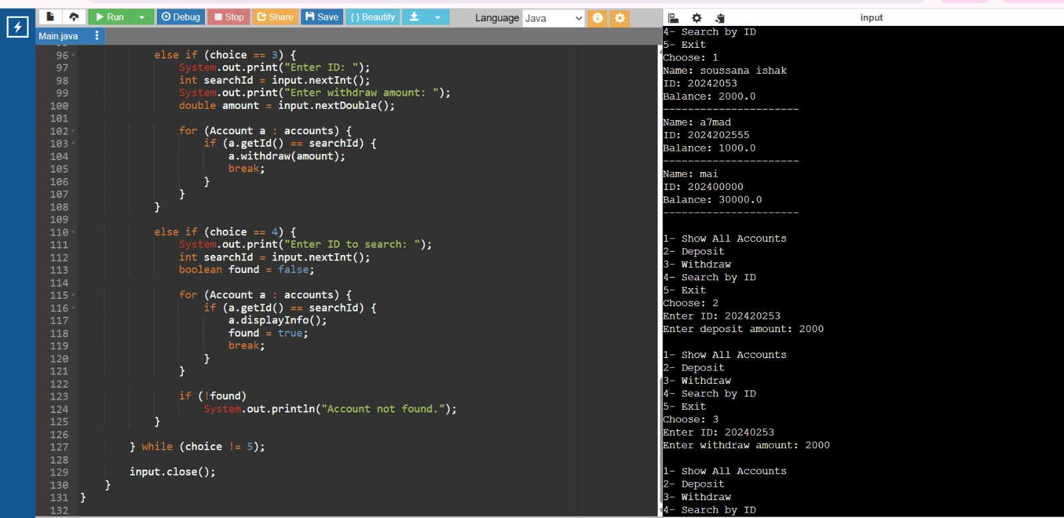
The link for the video:
https://drive.google.com/file/d/1Cvhk68u6_314bdfBjYEiFb7iZUnHPMBA/view?usp=sharing
import java.util.Scanner;
class Account {
private String name;
private int id;
private double balance;
public Account(String name, int id, double balance) {
this.name = name;
this.id = id;
this.balance = balance;
}
public int getId() {
return id;
}
public double getBalance() {
return balance;
}
public void deposit(double amount) {
balance += amount;
}
public void withdraw(double amount) {
if (amount <= balance)
balance -= amount;
else
System.out.println("Insufficient balance!");
}
public void displayInfo() {
System.out.println("Name: " + name);
System.out.println("ID: " + id);
System.out.println("Balance: " + balance);
System.out.println("----------------------");
}
}
public class Main {
public static void main(String[] args) {
Scanner input = new Scanner(System.in);
System.out.print("Enter number of accounts: ");
int n = input.nextInt();
Account[] accounts = new Account[n];
for (int i = 0; i < n; i++) {
input.nextLine();
System.out.println("Account " + (i + 1));
System.out.print("Name: ");
String name = input.nextLine();
System.out.print("ID: ");
int id = input.nextInt();
System.out.print("Balance: ");
double balance = input.nextDouble();
accounts[i] = new Account(name, id, balance);
}
int choice;
do {
System.out.println("\n1- Show All Accounts");
System.out.println("2- Deposit");
System.out.println("3- Withdraw");
System.out.println("4- Search by ID");
System.out.println("5- Exit");
System.out.print("Choose: ");
choice = input.nextInt();
if (choice == 1) {
for (Account a : accounts)
a.displayInfo();
}
else if (choice == 2) {
System.out.print("Enter ID: ");
int searchId = input.nextInt();
System.out.print("Enter deposit amount: ");
double amount = input.nextDouble();
for (Account a : accounts) {
if (a.getId() == searchId) {
a.deposit(amount);
break;
}
}
}
else if (choice == 3) {
System.out.print("Enter ID: ");
int searchId = input.nextInt();
System.out.print("Enter withdraw amount: ");
double amount = input.nextDouble();
for (Account a : accounts) {
if (a.getId() == searchId) {
a.withdraw(amount);
break;
}
}
}
else if (choice == 4) {
System.out.print("Enter ID to search: ");
int searchId = input.nextInt();
boolean found = false;
for (Account a : accounts) {
if (a.getId() == searchId) {
a.displayInfo();
found = true;
break;
}
}
if (!found)
System.out.println("Account not found.");
}
} while (choice != 5);
input.close();
}
}
Nawal’s app
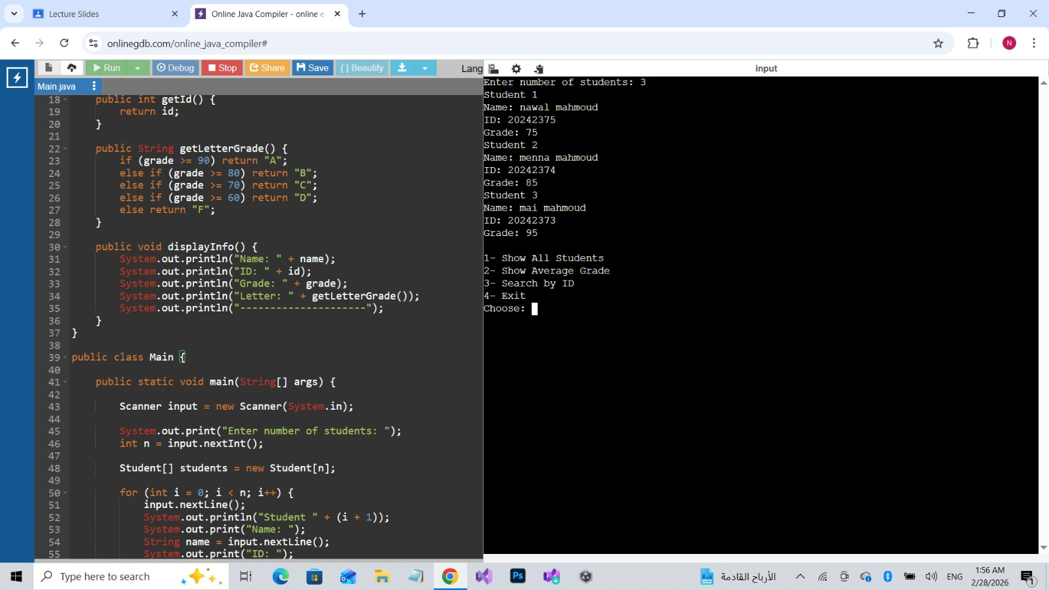

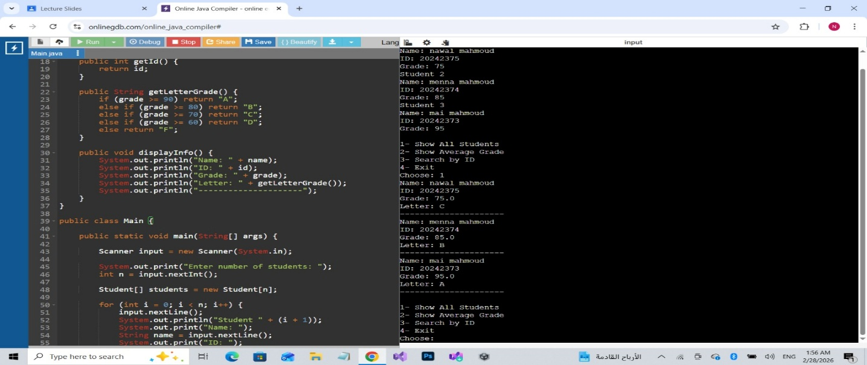
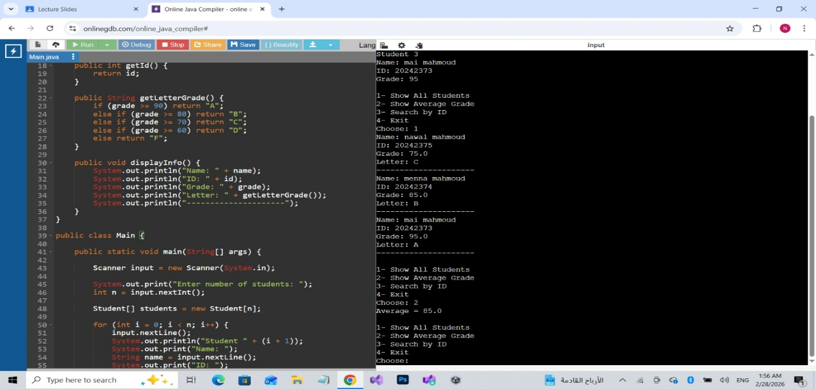
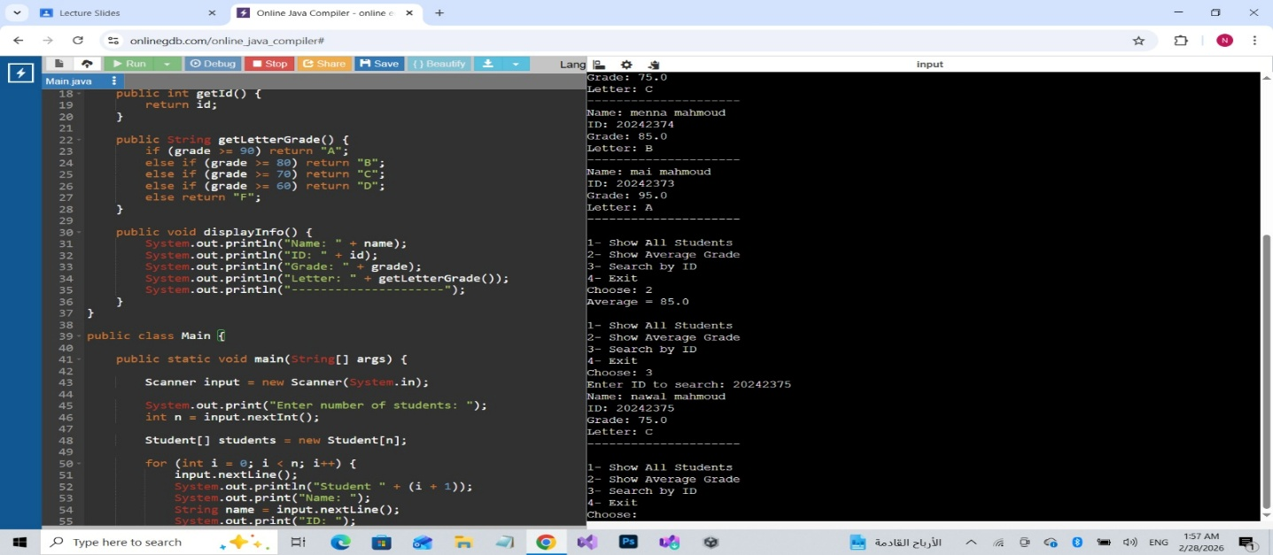
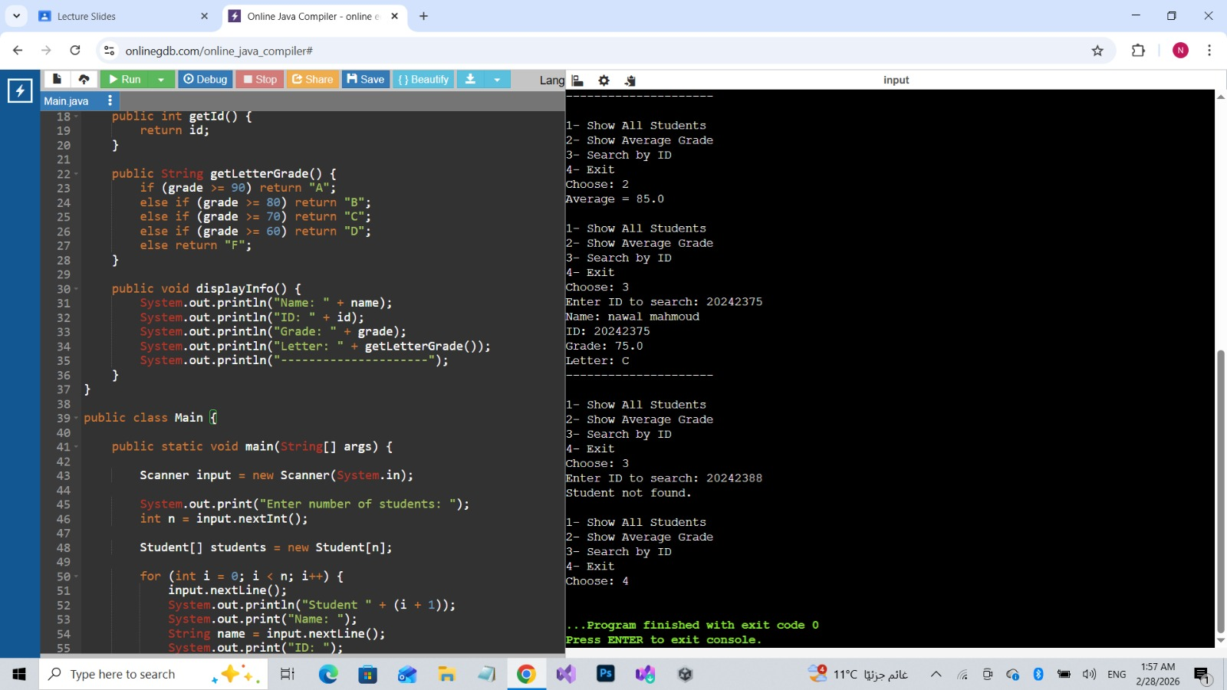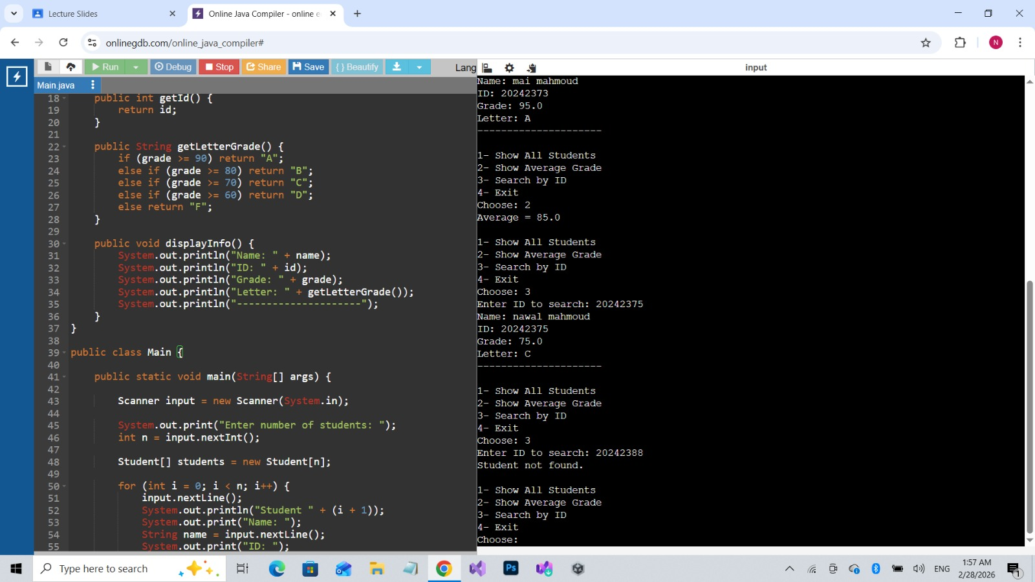
public static void main(String[] args) {
Scanner input = new Scanner(System.in);
System.out.print("Enter number of students: ");
int n = input.nextInt();
Student[] students = new Student[n];
for (int i = 0; i < n; i++) {
input.nextLine();
System.out.println("Student " + (i + 1));
System.out.print("Name: ");
String name = input.nextLine();
System.out.print("ID: ");
int id = input.nextInt();
System.out.print("Grade: ");
double grade = input.nextDouble();
students[i] = new Student(name, id, grade);
}
int choice;
do {
System.out.println("\n1- Show All Students");
System.out.println("2- Show Average Grade");
System.out.println("3- Search by ID");
System.out.println("4- Exit");
System.out.print("Choose: ");
choice = input.nextInt();
if (choice == 1) {
for (Student s : students)
s.displayInfo();
}
else if (choice == 2) {
double sum = 0;
for (Student s : students)
sum += s.getGrade();
System.out.println("Average = " + (sum / n));
}
else if (choice == 3) {
System.out.print("Enter ID to search: ");
int searchId = input.nextInt();
boolean found = false;
for (Student s : students) {
if (s.getId() == searchId) {
s.displayInfo();
found = true;
break;
}
}
if (!found)
System.out.println("Student not found.");
}
} while (choice != 4);
input.close();
}
}
Abanob’s app
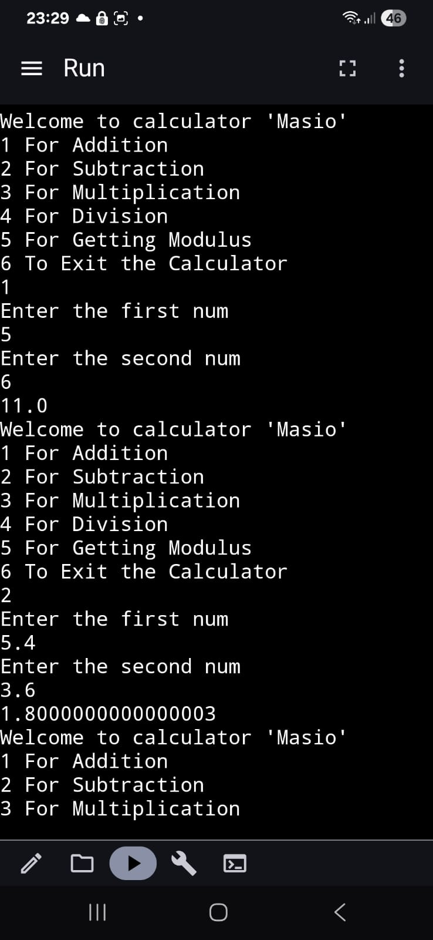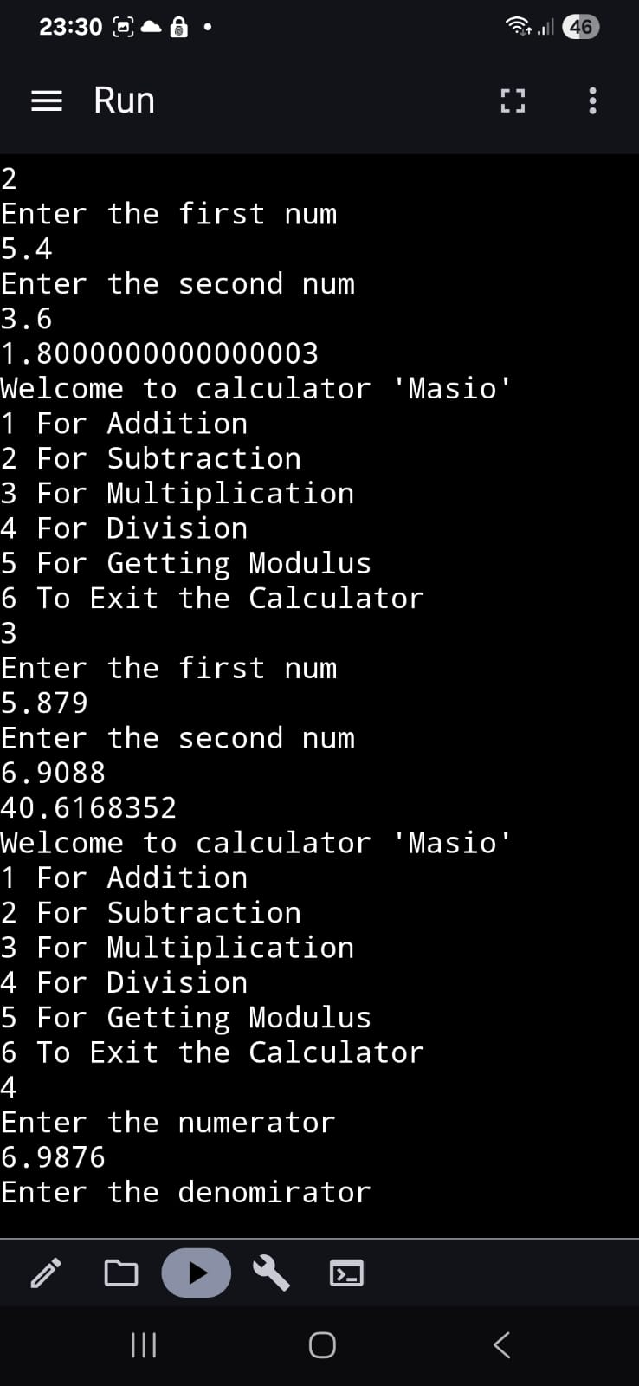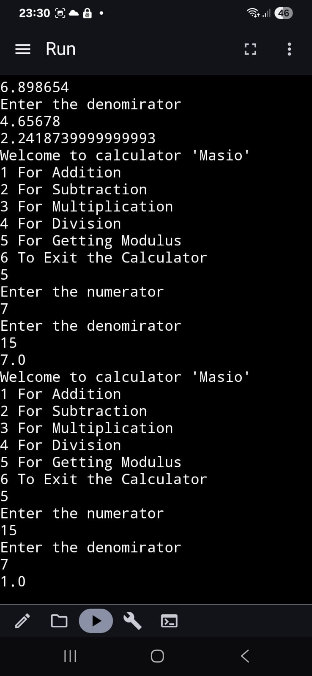
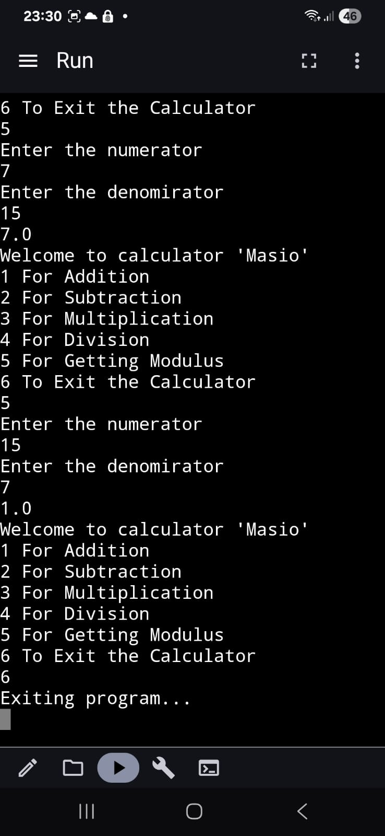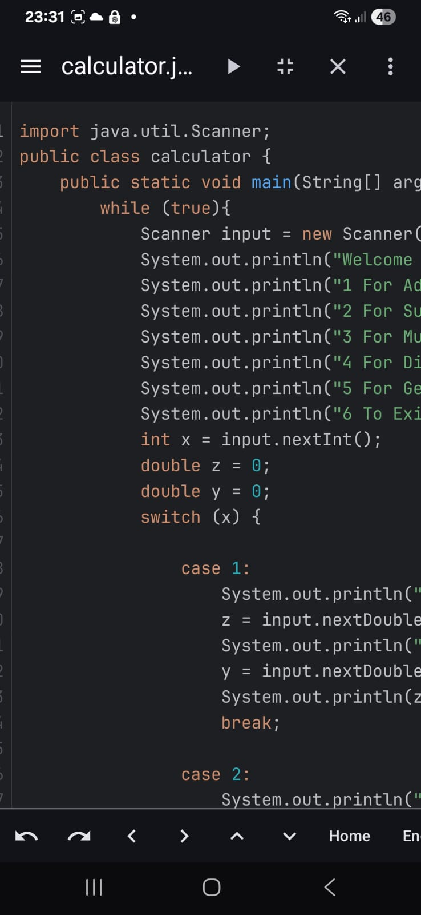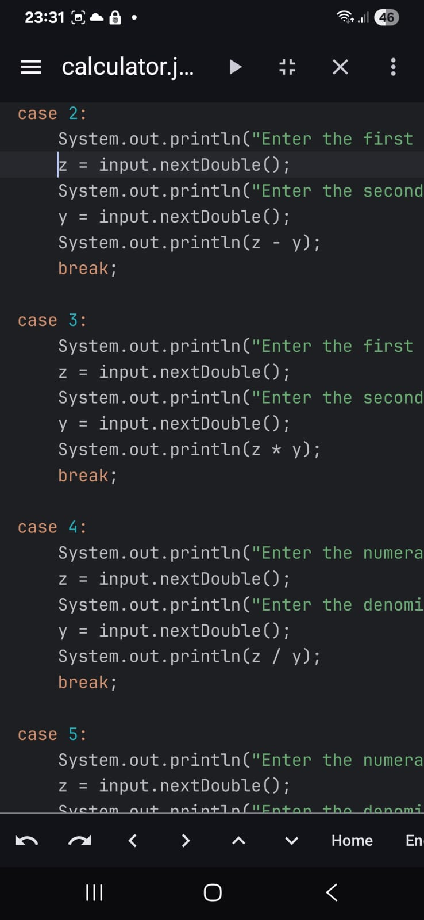
Link for the video:
https://drive.google.com/drive/folders/1VYn12M0_LFsLiWKGbSAMmWzmKbiK1A8B?usp=drive_link

import java.util.Scanner;
public class calculator {
public static void main(String[] args) {
while (true){
Scanner input = new Scanner(System.in);
System.out.println("Welcome to calculator 'Masio'");
System.out.println("1 For Addition");
System.out.println("2 For Subtraction");
System.out.println("3 For Multiplication");
System.out.println("4 For Division");
System.out.println("5 For Getting Modulus");
System.out.println("6 To Exit the Calculator");
int x = input.nextInt();
double z = 0;
double y = 0;
switch (x) {
case 1:
System.out.println("Enter the first num");
z = input.nextDouble();
System.out.println("Enter the second num");
y = input.nextDouble();
System.out.println(z + y);
break;
case 2:
System.out.println("Enter the first num");
z = input.nextDouble();
System.out.println("Enter the second num");
y = input.nextDouble();
System.out.println(z - y);
break;
case 3:
System.out.println("Enter the first num");
z = input.nextDouble();
System.out.println("Enter the second num");
y = input.nextDouble();
System.out.println(z * y);
break;
case 4:
System.out.println("Enter the numerator");
z = input.nextDouble();
System.out.println("Enter the denomirator");
y = input.nextDouble();
System.out.println(z / y);
break;
case 5:
System.out.println("Enter the numerator");
z = input.nextDouble();
System.out.println("Enter the denomirator");
y = input.nextDouble();
System.out.println(z % y);
break;
case 6:
System.out.println("Exiting program...");
return;
default:
System.out.println("Invalid choice. Please select one number from 1 to 6.\n");
}
}
}
}
Youssef’s app
https://drive.google.com/file/d/1MKfCbLMQ87S2ZBQaXSaeJdu-6kz3Y-OU/view?usp=drive_link
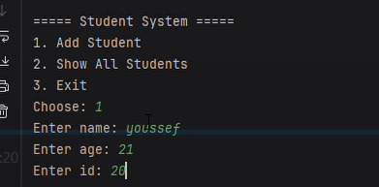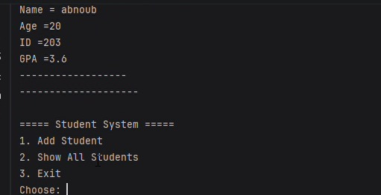

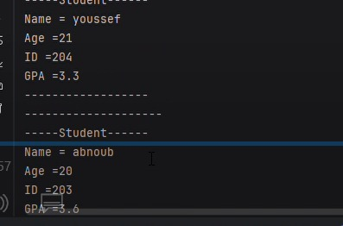

Main Function

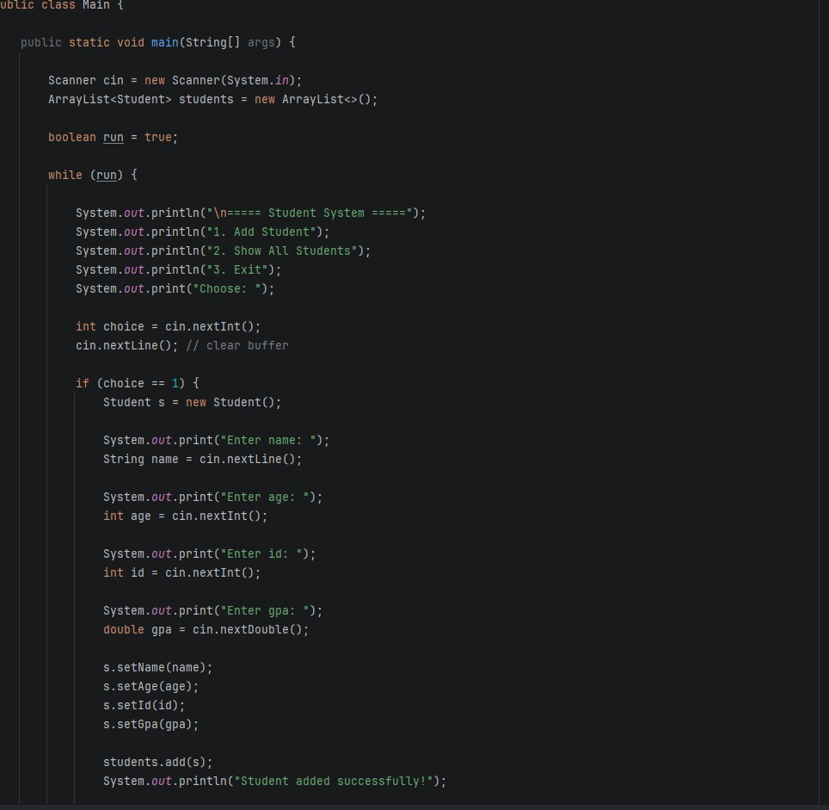

Link for git hub repo
https://github.com/Youssef-Osama22/assigment-soft-eng-1.git

Task 2
1.
LCNC Tools

What they can do:
Build apps that can be used in common life.
Create screens with buttons, text, images, and lists.

Benefits:
Anyone can start without high coding skills.
Apps can be built much quicker than traditional coding

Quality of systems produced:
Apps can be very high quality, including custom UI, responsive design, and secure data handling.

Will they take the job of developers?
They lower the barrier to app creation and lets non-developers make apps quickly, but it does not fully replace developers. For advanced logic, performance optimization, custom animations, and large systems, developers are still needed.
2.
Thunkable is designed primarily for mobile app development. It focuses on building apps that run natively on Android and iOS devices using a visual drag-and-drop interface combined with logic blocks.
Bubble is designed for web application development, allowing users to create dynamic websites and web apps with databases, workflows, and responsive design — all without writing code.
3.
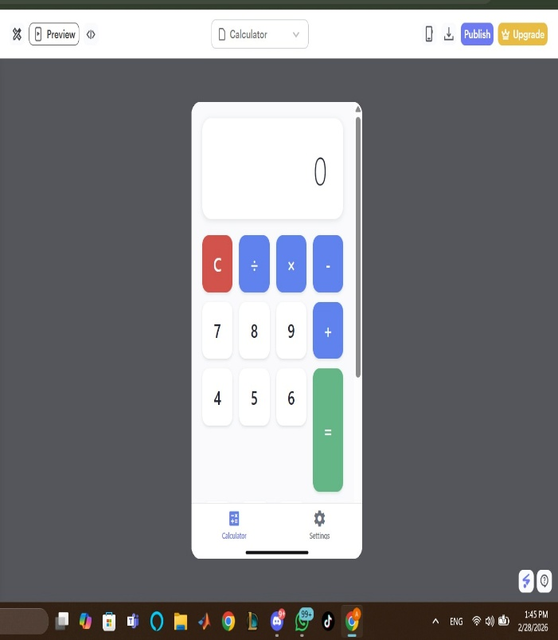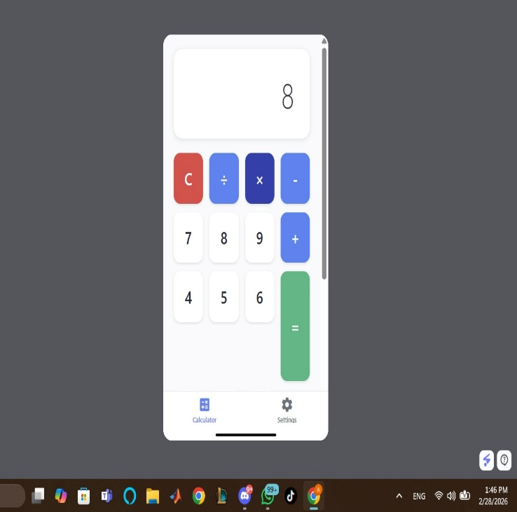
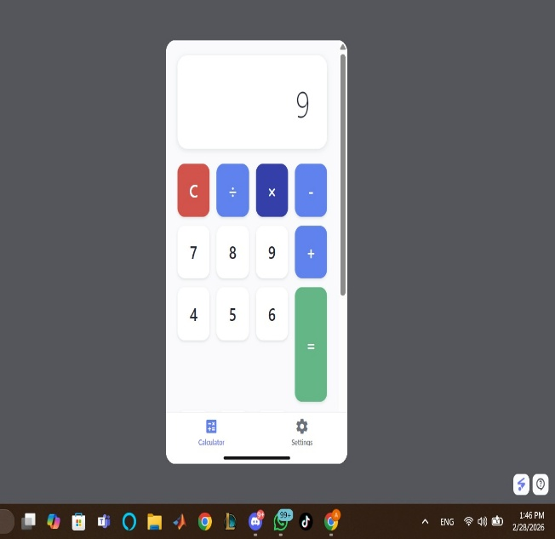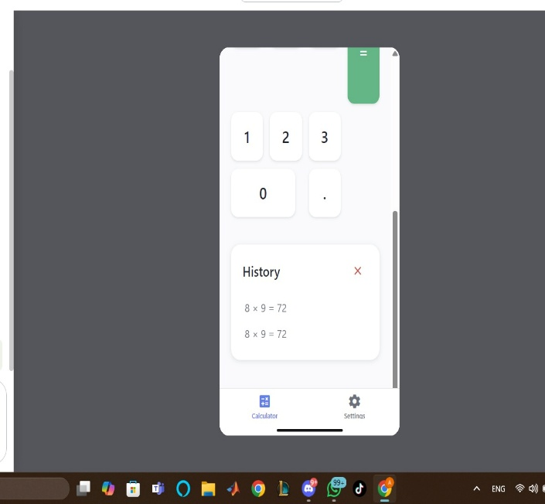
https://drive.google.com/file/d/1yqRhv93FqRihZoxxmuNU1ITAr4gW1PjF/view?usp=drive_link
Using Thunkable tool
Task 3

Resources
https://youtube.com/playlist?list=PL8DDsWuvM_EXvdiwpTPRIJ7s7iGfczB2P&si=XokajGtlD5Jn5NAy
https://youtu.be/YZ_E92IfFbs?si=HMEIpsnytwVQGjMT
https://youtu.be/Xhx5A4sNgy8?si=hT6y2JLeBvXSlNPW
Routes courses

